|  |  |  |  |  |  |  |  |  |  |  |  |  |  |  |
| --- | --- | --- | --- | --- | --- | --- | --- | --- | --- | --- | --- | --- | --- | --- |
| **MAD Project Evaluation 2 – Regular Intake 2021** | | | | | | | | | | | | | | |
| **Project Name:** | Kylix Medusa | | **Batch: Malabe**  **G4.2** | **<Lecture Group>** | | | |  |  |  |  | | |
| Student ID | Student Name | Integrated system using a repository (Out of 5) | Marketing the app using a video clip published in a social media account (eg: LinkedIn) (Out of 10) | CRUD Function completeness (Out of 20) | Database connectivity (Out of 5) | Usability (Out of 5) | Validations (Out of 5) | Good coding practice (Out of 5) | Out of box features (Out of 10) | Test cases (Out of 10) | Report (Out of 10) | Q & A (Out of 15) | Total (Out of 100) |
| IT20111656 | Navoda M.R. |  |  |  |  |  |  |  |  |  |  |  |  |
| IT20144562 | Weerasooriya O.W.R.Y. |  |  |  |  |  |  |  |  |  |  |
| IT20034504 | Siriwardhana A.U.A. |  |  |  |  |  |  |  |  |  |  |
| IT20152246 | Sonali L.D.A. |  |  |  |  |  |  |  |  |  |  |
|  |  |  |  |  |  |  |  |  |  |  |  |

Git Repository Link: https://github.com/RashNV/TriposoTourGuide.git

Link for the video in social media: https://www.linkedin.com/posts/rashmi-navoda-490b34217_mad-mobileappdevelopment-sliit-activity-6847861954611089408-HB_P

----------------------------------------------------------------------------------------------------------For Evaluators-------------------------------------------------------------------------------------

Evaluator’s name:

Comments:

.

**Introduction to the Project**



Since early days Sri Lanka is popular for attractive and best tourism places. Thus, tourists are more attractive to visit Sri Lanka. For that reason, we base our project on the Tour Guide mobile app. Personalized mobile travel guides can give individual travelers a better experience in a tourist destination by providing an individually customized experience that suits their personal preferences more than the standard guidebooks can offer.

“Triposo” app allows the tourists to choose their own tourism guidance according to their preference. They can login to the application and search for the events, hotels and restaurants and also about the travelling places according to their preference. They can also check about the top reviews of the tourist about the places and the experience they got.

The aims of this project are to provide a prototype of a mobile tourist guide, through “Triposo” app which focuses on the needs of tourists and especially tourists traveling in groups. The objectives of this project are to provide a mobile travel guide prototype that focuses on the needs of travelers.

There are four main functionalities we identified in this system

* Customer account and customer review Management
* Events Management
* Tourist site Management
* Hotel Management

**IT20111656 – Login & Customer review Management**

**Crud operations and the entire functionality of the component.**

In our tour guiding app the customer review management and login function was done by myself. Any customer can login to this app freely without creating an account as guest. Admins can login to the system by providing their username and password. Customer can make a review about their experiences of using the Triposo app and about their feelings throughout their journey.

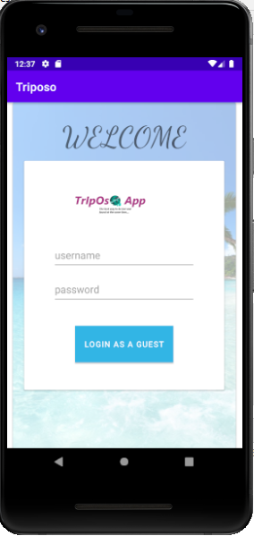

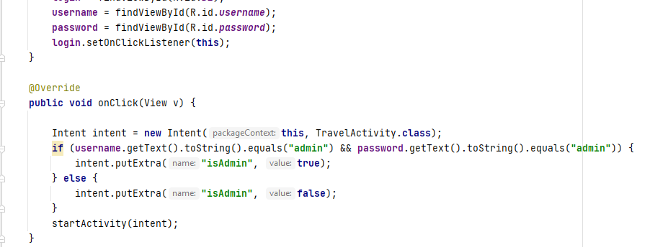

Adding reviews are handled by my function. Simply the users can fill the below form and add their review about their experience.

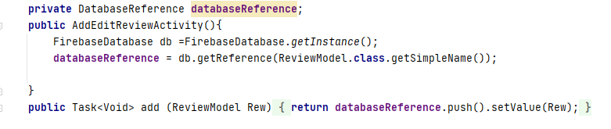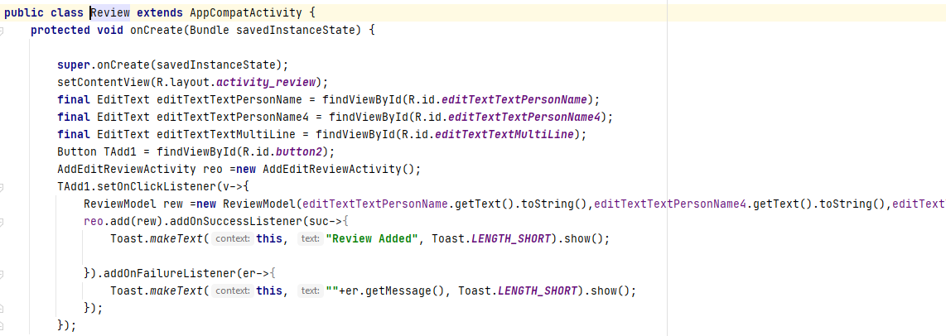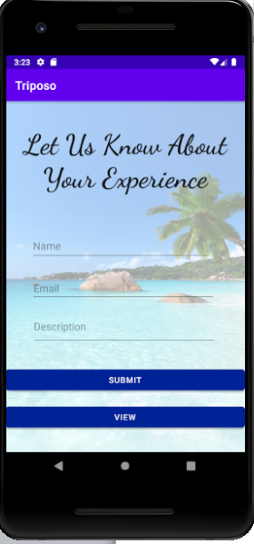

Customers can view their reviews by clicking the ‘**view**’ button.

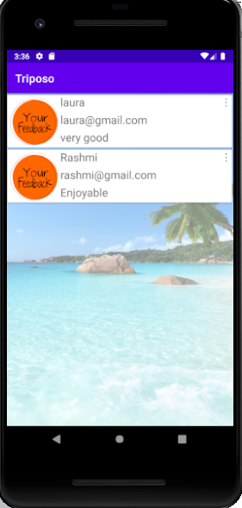

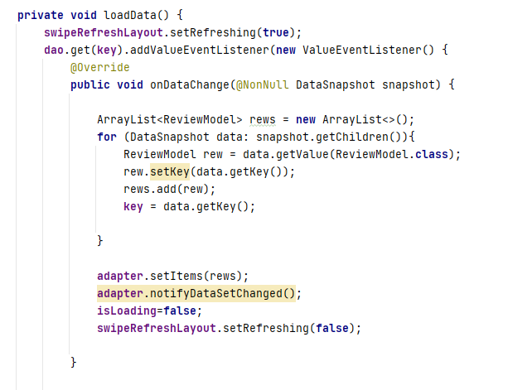

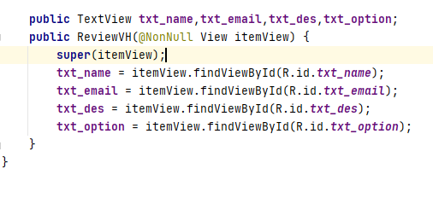

Customers can edit or remove their comments by clicking the side dots in the right corner of each review.

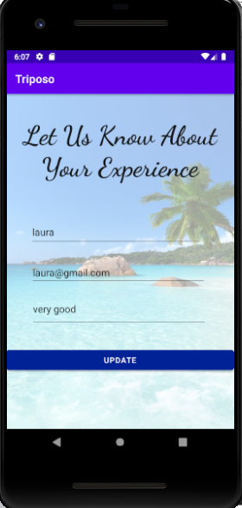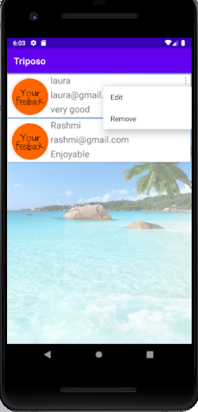

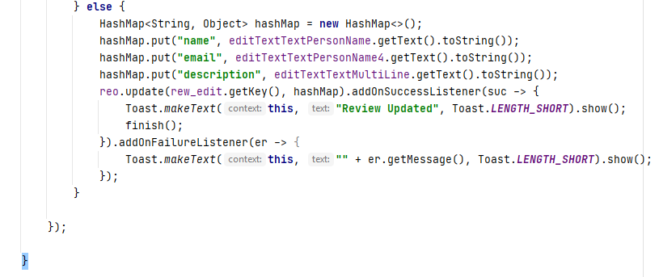

Update

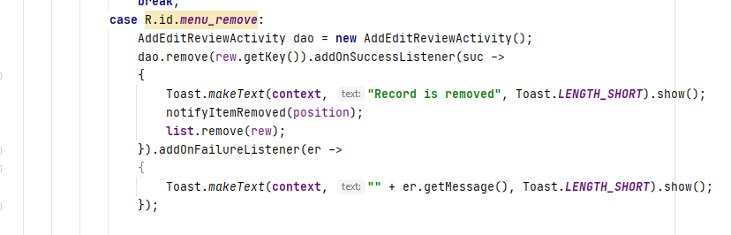

Delete

Test Cases: -

* No blanks allowed when adding a review- error message will popup
* Should include valid email
* Word limited to 200 in comment section

Once user updates the data they can view the updated data through the view section. After each an action performed by the user a confirmation message will popup.

**IT20144562 - Events Management (Things that can do in each place)**

**Crud operations and the entire functionality of the component.**

In our tour guide system, the event management is a very important part. Events that tourists can enjoy are displayed in this system. The key people of this event management section are admin and user. In here the admin can search for events, add events, edit or delete an event. However, the user can only search for an event and get the details.

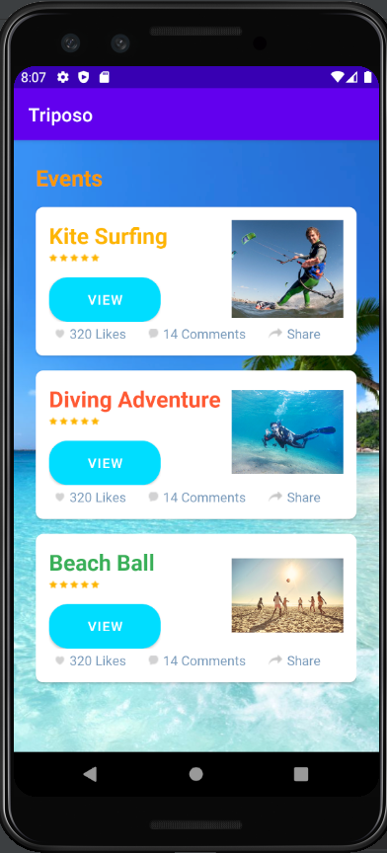**View Event**

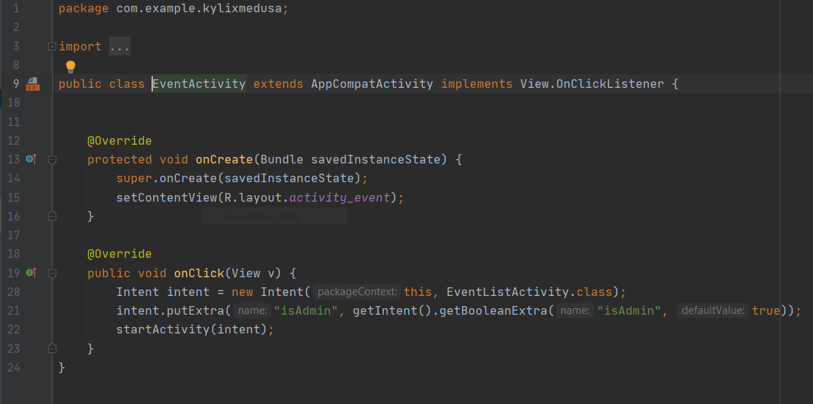

Here first the admin/user logs into the system and then all the events related to them are displayed.

Once the user can/admin read or view the events. Then they can search or selection for an event after selecting one of the event, it will navigate to the places that are available. It will provide information such as price details. If the user requires additional information on the events, they can refer to this information by tapping to “see more” button. In their user can get all details corresponding to that event.

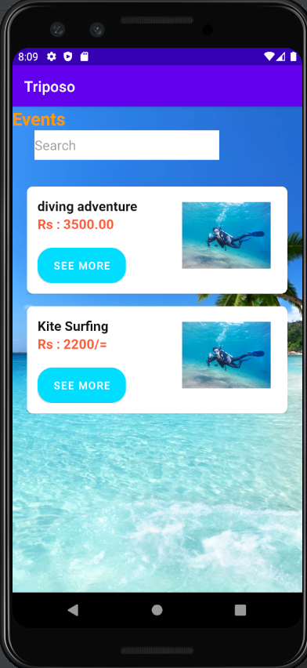 **Search events/view**

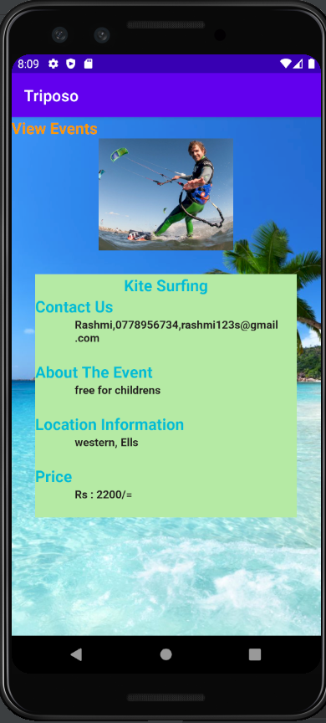

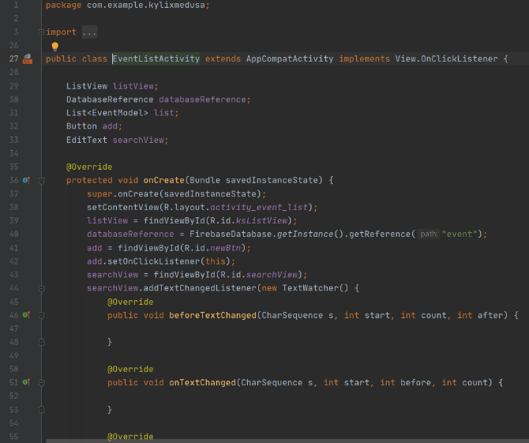

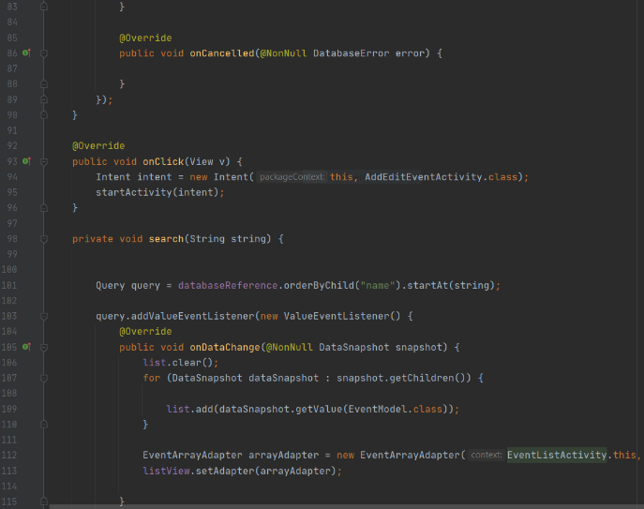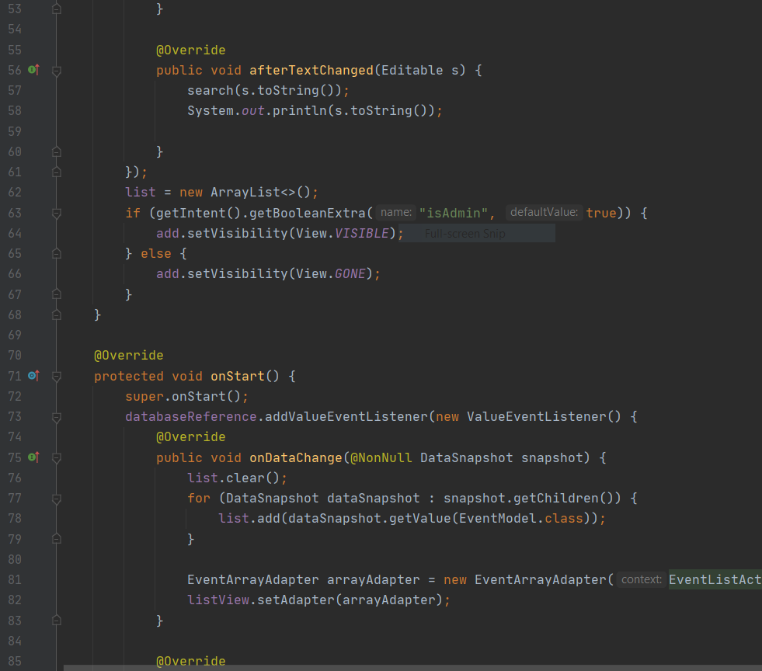

**ADD Event**

According to the adding events, in the admin panel admin can upload all the event details by filling the details. As you can see, there’s a button called ‘’ADD’’ in the top of the screen. An Admin can add new events by using that and All the fields are must be completed. If the event is added the success notification appears when the admin enters new event.

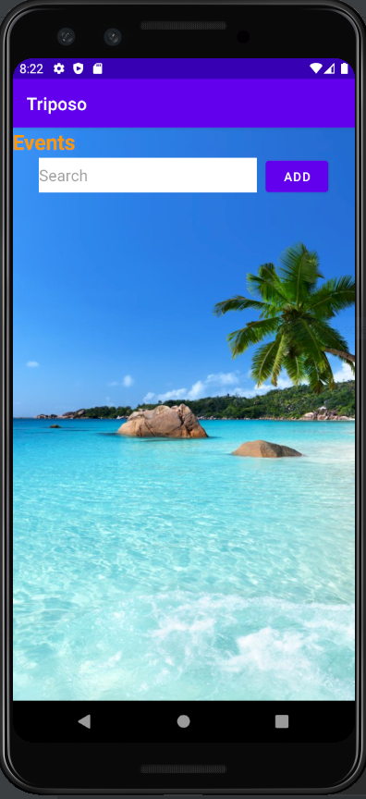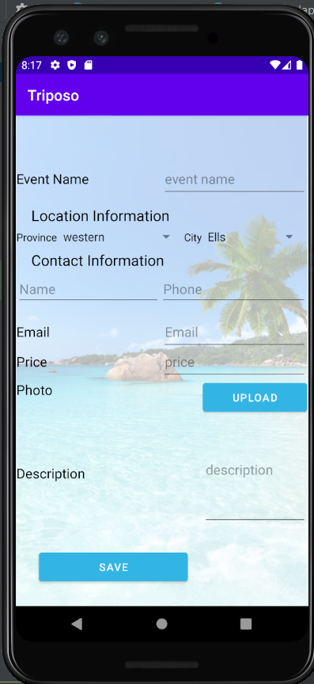

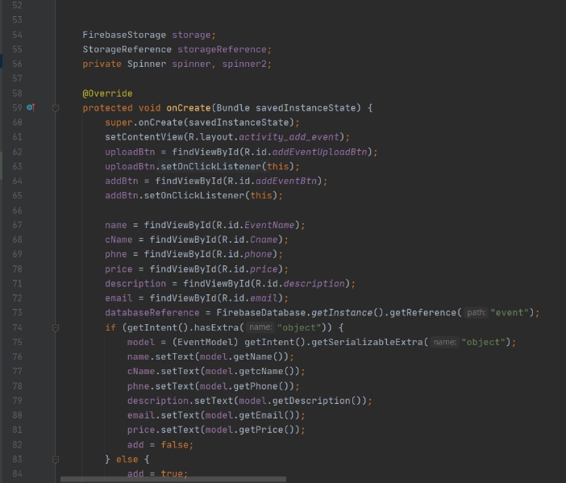

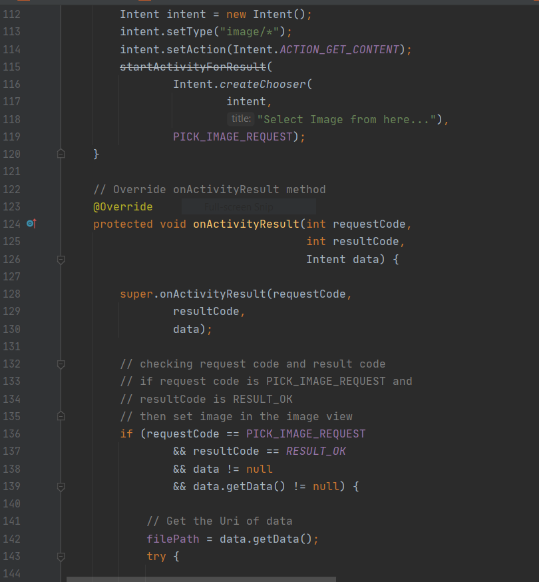

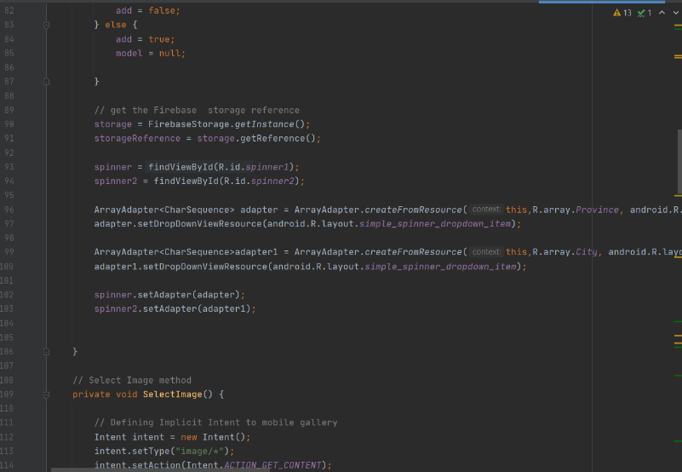

**Edit and Delete Event**

When the admin adds all the details successfully, it will navigate to the Events. In their admin click “see more” button, it will navigate to the “View Event”. In their admin can change the inserted details when it is necessary by clicking MODIFY button. After the editing the details he should click the “save” button. And also, the admin has the ability to remove events from the application. When he wants to remove something he has to click the DELETE button in the application. Then, it will successfully delete from the application.

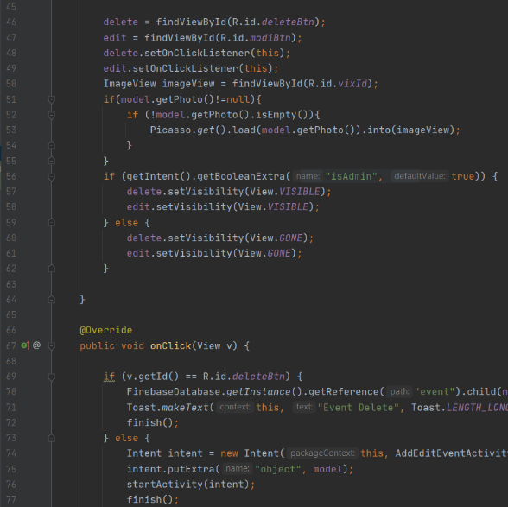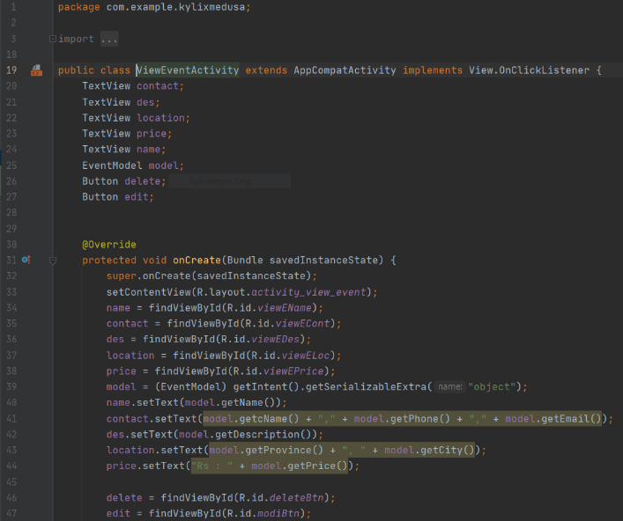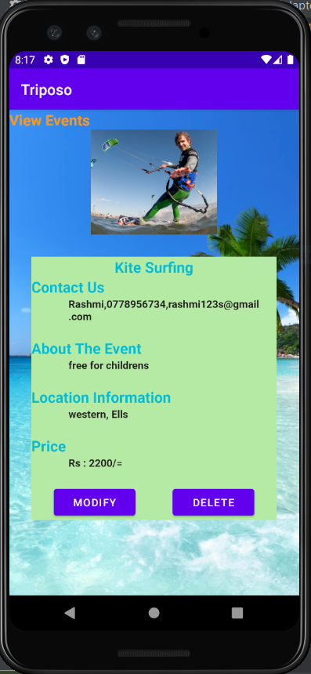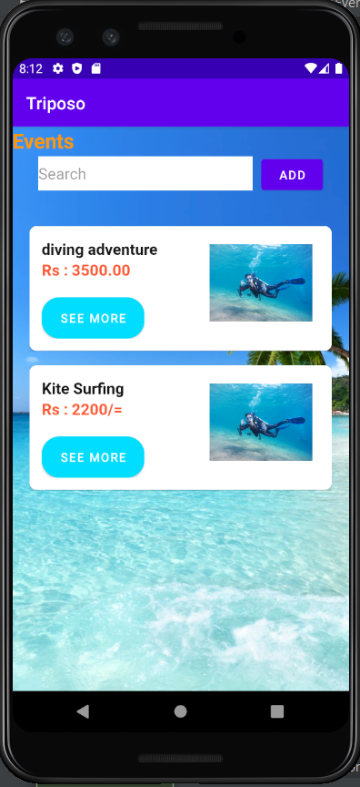

Test Cases –

* After adding all the details – A toast message will be displayed
* After modifying and deleting the details, toast messages will be displayed saying details modify and delete.
* When the admin adds some event to the system, after he adds it and clicks the save button, a dialog box will pop up to confirm it.
* When the admin modifies or delete some event, after he modified and delete it and clicks the save button, a dialog box will pop up to confirm it.
* When we upload a photo, if we forget to upload a photo, the system will upload a Photo. It is automatically generated by the system.
* If the Phone Number is more than 10 digits, an error will occur
* If the email is not 8 characters or more, an error will appear saying “Enter the valid Email address”.
* No blanks allowed and error message will popup.
* Word limited to 200 in ADD Event - description section (an error message will popup)

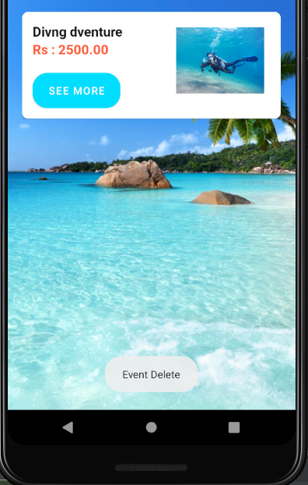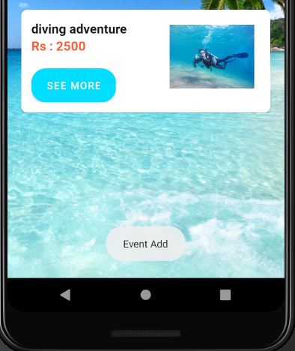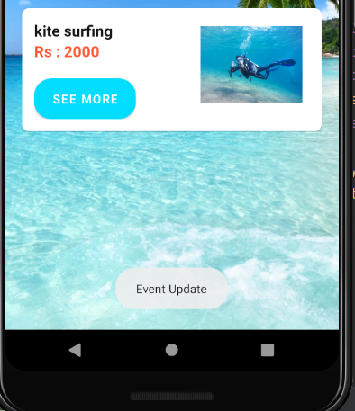

**IT20034504 – Tourists Site Management (Places where we can travel)**

**Crud operations and the entire functionality of the component.**

This is one of the most important part in our tour guide app. In the Tourist Site Management Function Admin can do insertion, update and deletion while the referrer is only allowed to do search and view details options.

**View Travel Places**

The user or admin both can view and read the travel places details and also they can search any place they wish to know by using search bar. After selecting the place, it will navigate to the places that are available. There’s a ‘’see more’’ button under each section a user can go through with that for more information. In there we provide some information such as locations, descriptions for the users.

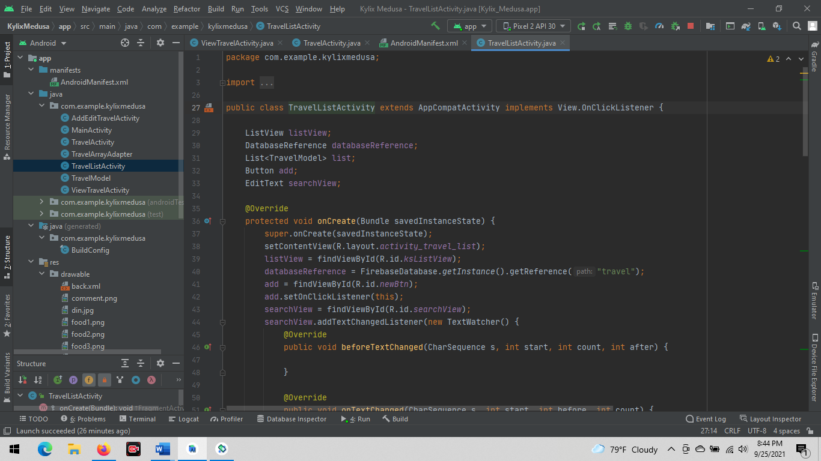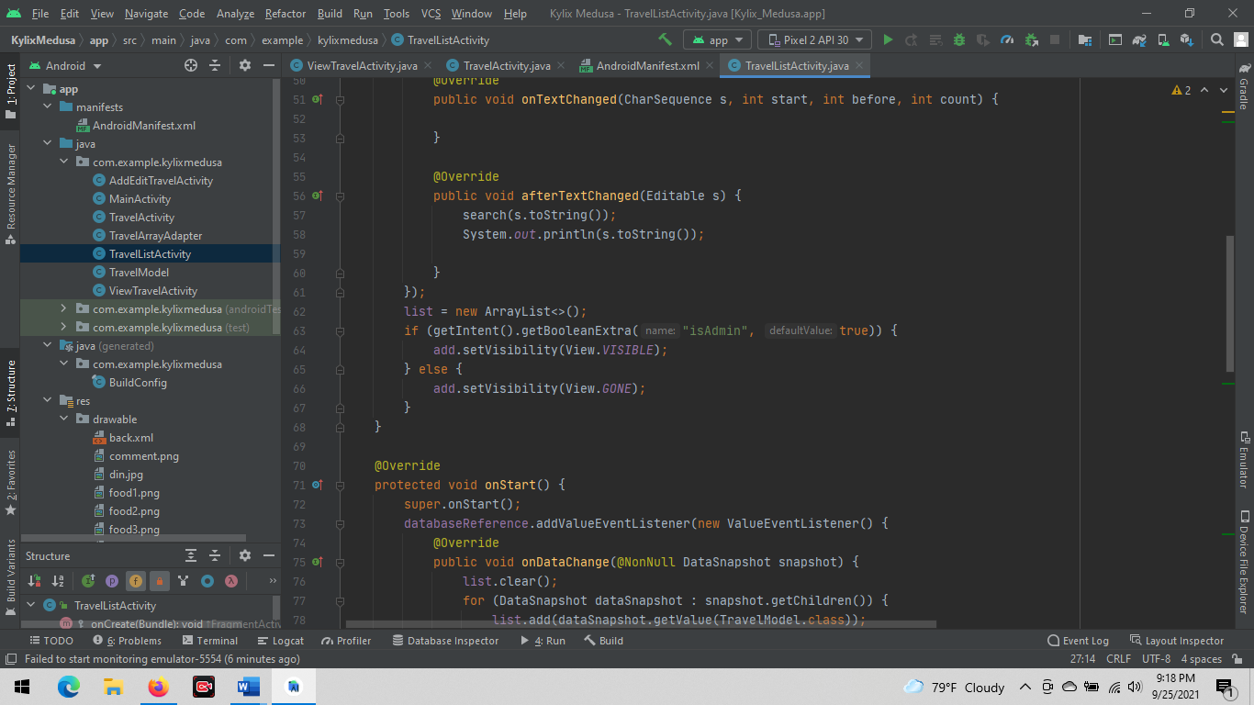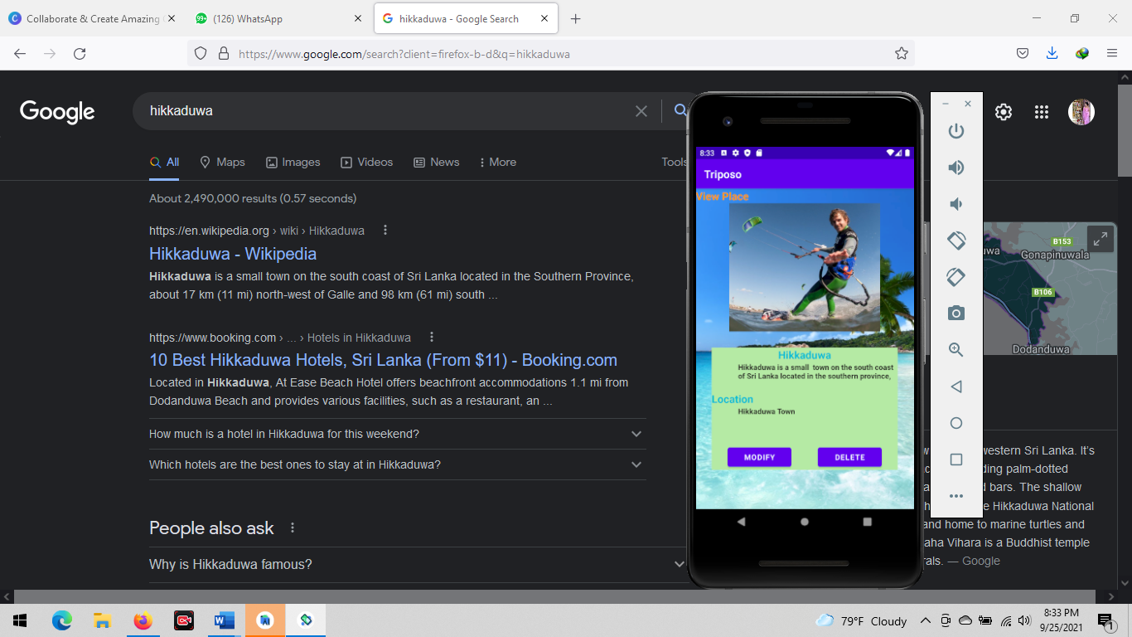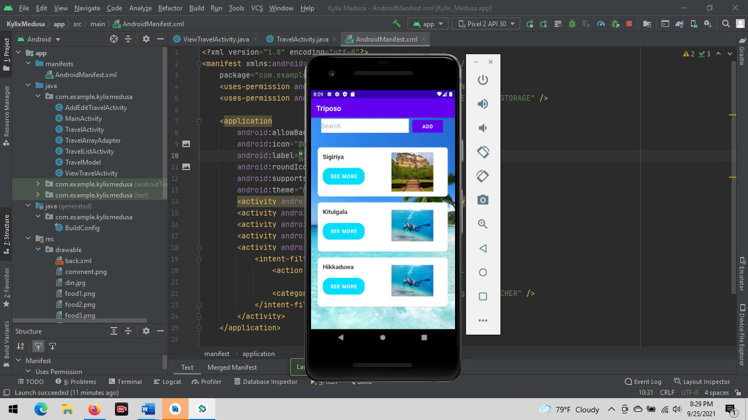

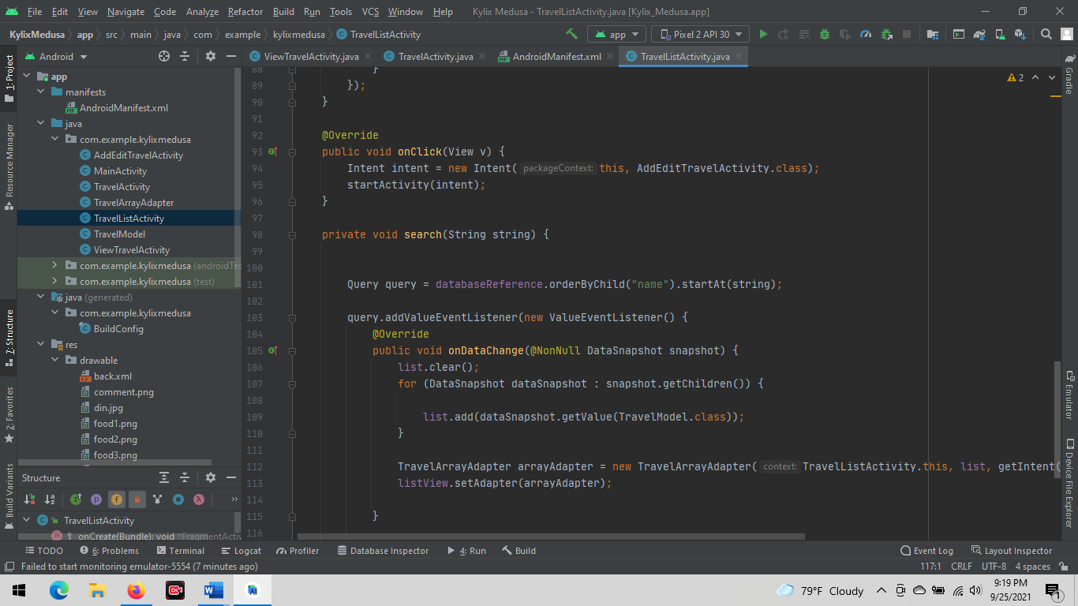

**Add New Travel Place.**

This function is only accessible for the admin panel. In the admin panel admin can upload all the travel place details by filling the add new forum. As you can see, there’s a button called ‘’ADD’’ in the top of the screen. An Admin can add new places by using that. All the fields are must be completed. If the travel place is added the successful notification will appear when the admin enters new travel place.

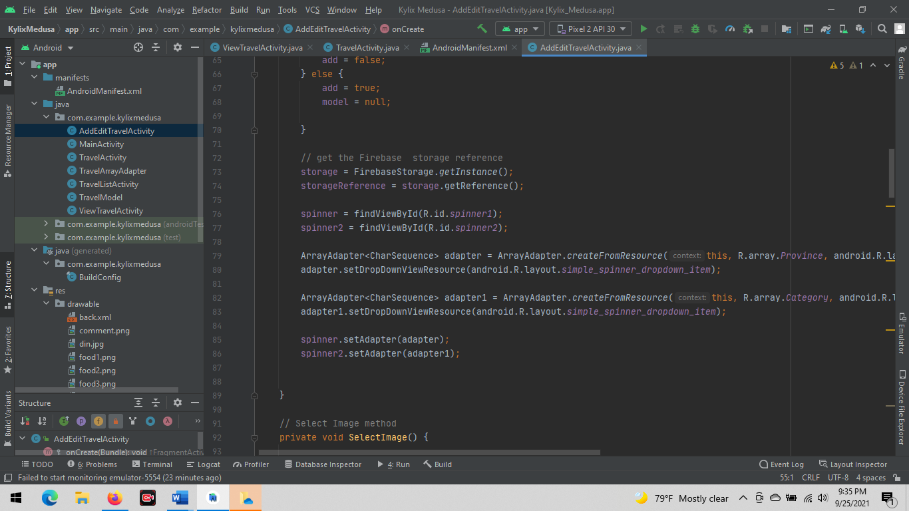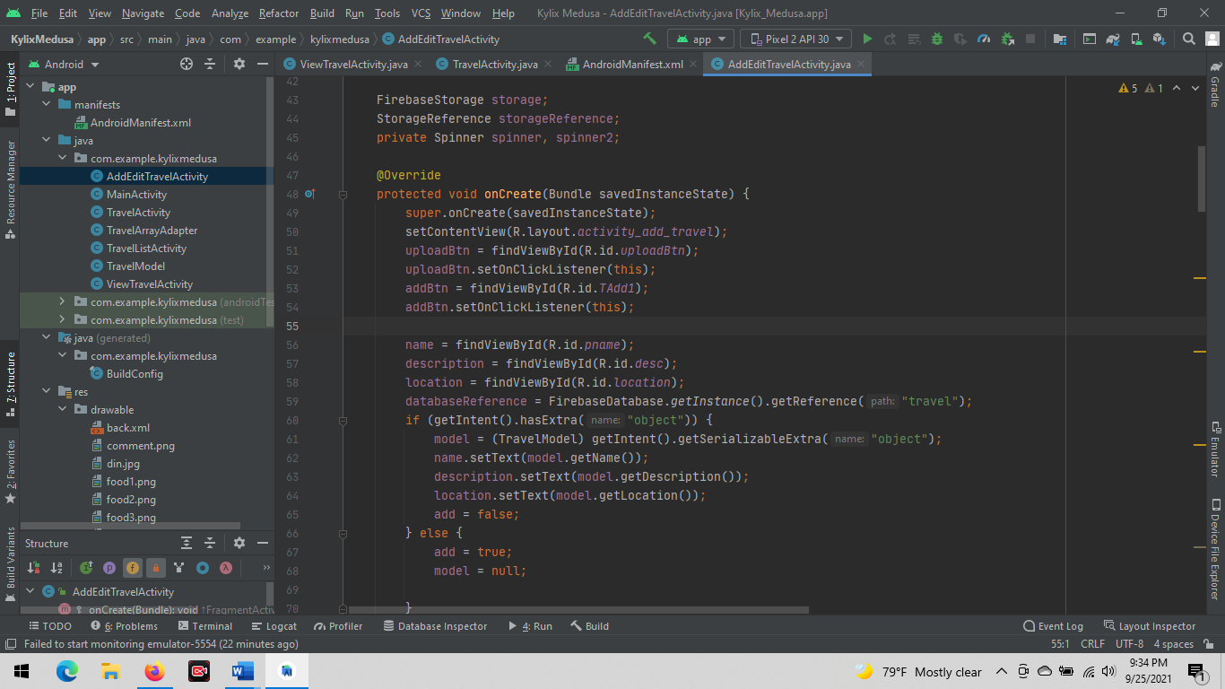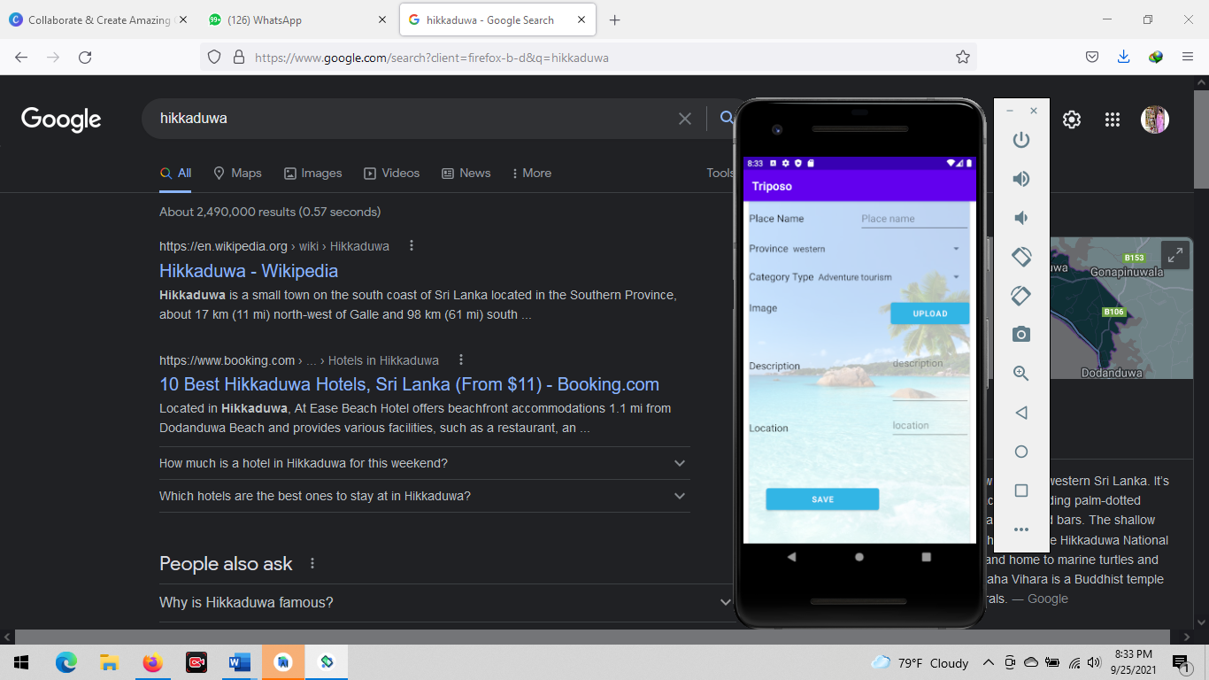

**Edit & Delete Travel Place.**

Due to any reason, admin can delete the deserved places from the application. The admin has the ability to remove places from the application. When he wants to delete something, he can go through with the Delete button in the app. And if he wants to update something, he can simply go with ‘’Modify’’ button. Once he completed the update he can save and update it by clicking “Save” button in below.

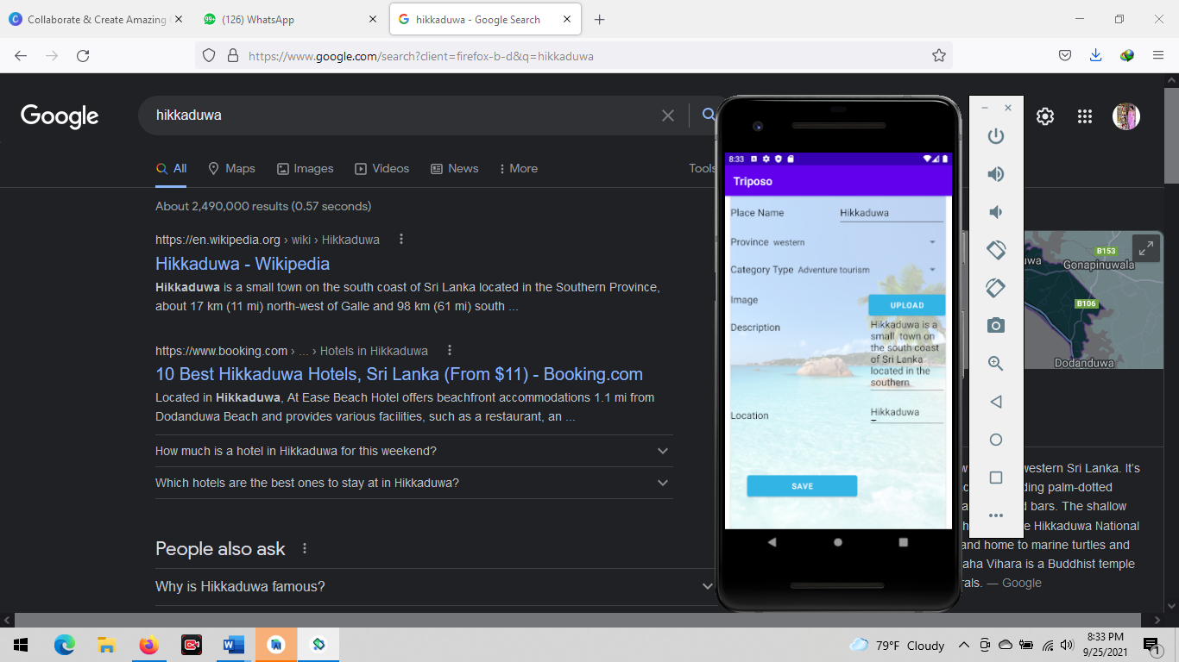

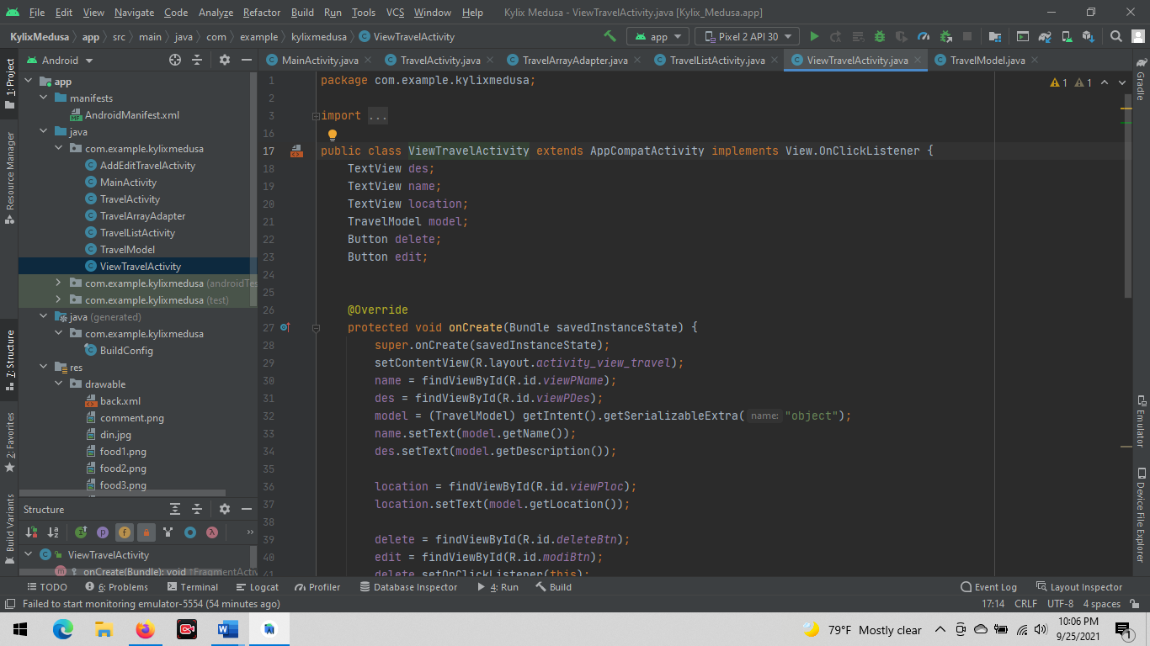

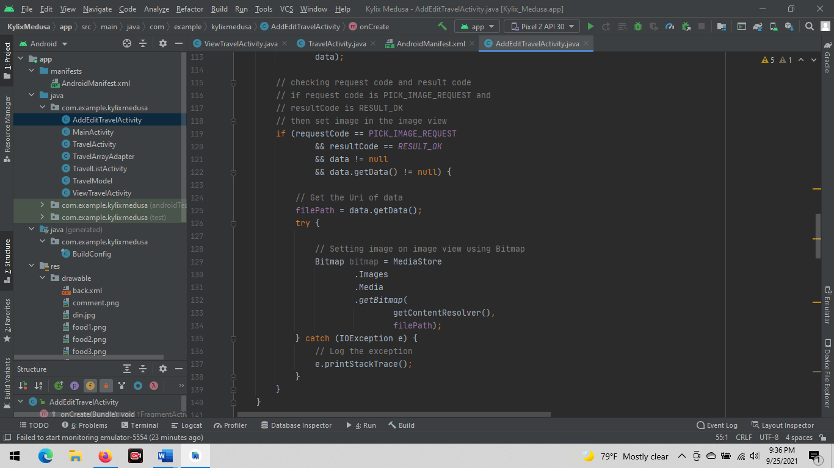

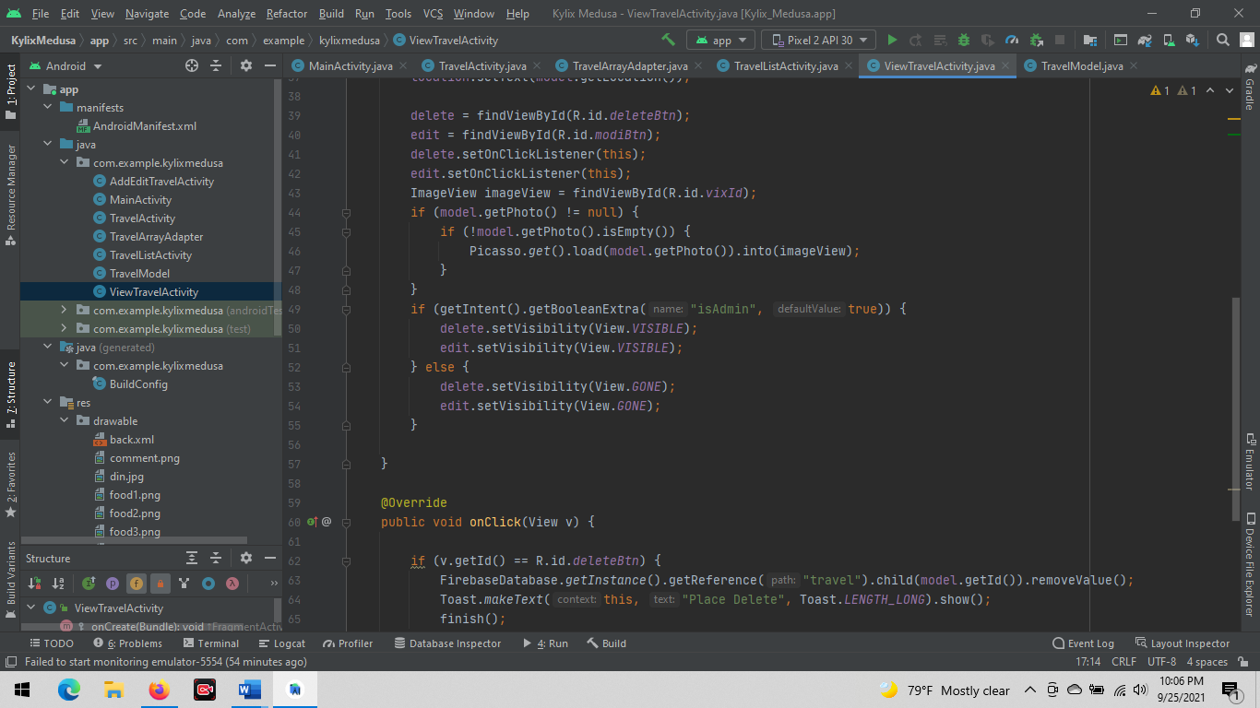

Test Cases-

* When we upload a photo, if we forget to upload a photo, the system will upload a Photo. It is automatically generated by the system.
* No blanks allowed and error message will popup.
* Word limited to 200 in ADD Travel place - description section (an error message will popup).
* When the admin adds some place to the system, after he adds it and clicks the save button, a dialog box will pop up to confirm it.

**IT20152246 – Hotel Management**

**Crud operations and the entire functionality of the component.**

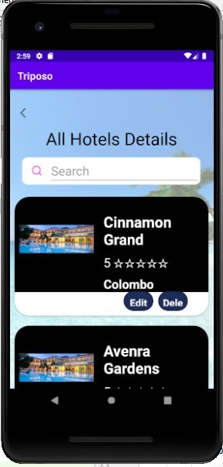Our app is “Triposo” tour guide application. This part belongs to hotels and restaurants. In this function, both user and admin can search for hotels. And in here only admin has access to handle these three functions ADD, UPDATE and DELETE

SEARCH Hotel - By search bar, users can search a city that they need, or in below, there is a dropdown list and by using it also you can easily search your places. After searching for your city or district all the top destinations can be seen. By search result menu, you can see the main details of each hotel and if you need more details by clicking view details you can enter that hotel page. There you can see an overview of the hotel and on that page, you can see full details of the hotel

By changing another tab, you can choose your rooms, hotel package’s and their prices. And also, by amenities tab users can easily see the facilities of each hotel. And some hotels will display their discount packages and extra-facilities which given by them in their amenities tab. If users are interested in packages they can contact through calling or sending a mail to hotels. And these parts belong to the frontend side of the application

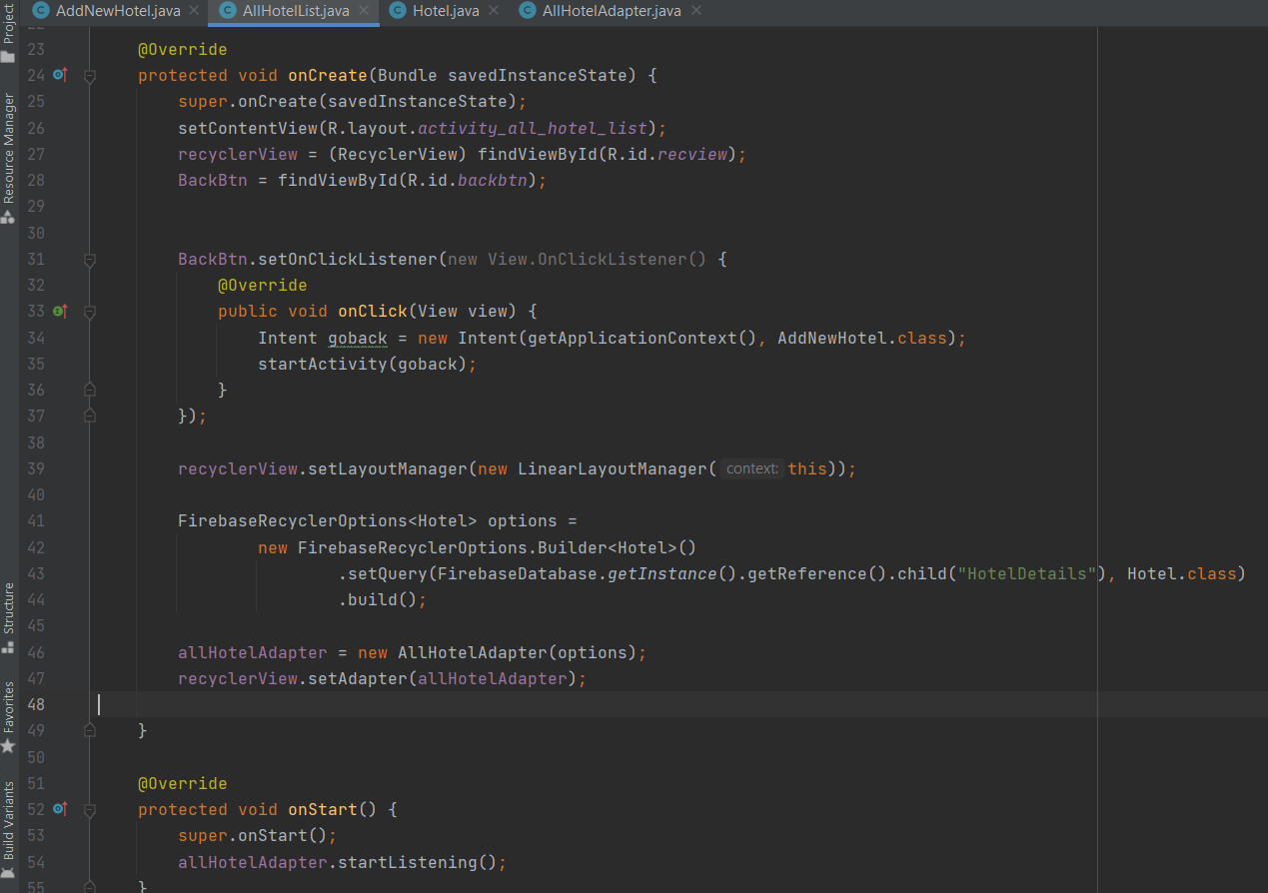

ADD New Hotel - By add hotels function, admin can add hotels to the app. Mainly hotel name, district, hotel type, location, prize details of hotel packages, phone, and a brief description of the hotels can be added. All the fields must be completed. When the admin adds details of a hotel and by clicking “Add Hotel” button, system will display a success notification.

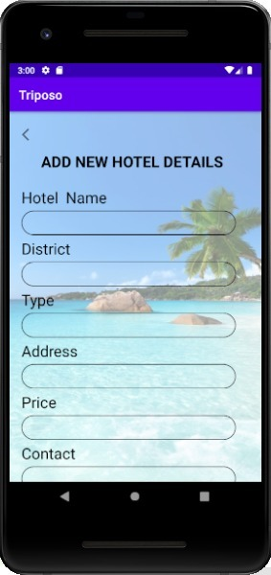

And in here, all the fields such as hotel name, district, type, address, price and contact are consisting of validations. Also, in here, any of the field should not be kept empty without recording data. Therefore, all the required fields should be filled in order to add details of a new hotel.

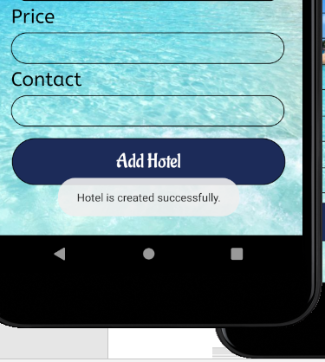After recording data to all the required fields, admin can click Add Hotel button. So, after clicking Add Hotel button system will check the validations and if the recorded details are valid then it will display a toast message as “Hotel is created successfully”. So, after displaying this toast message, the inserted details will be recorded in the database successful

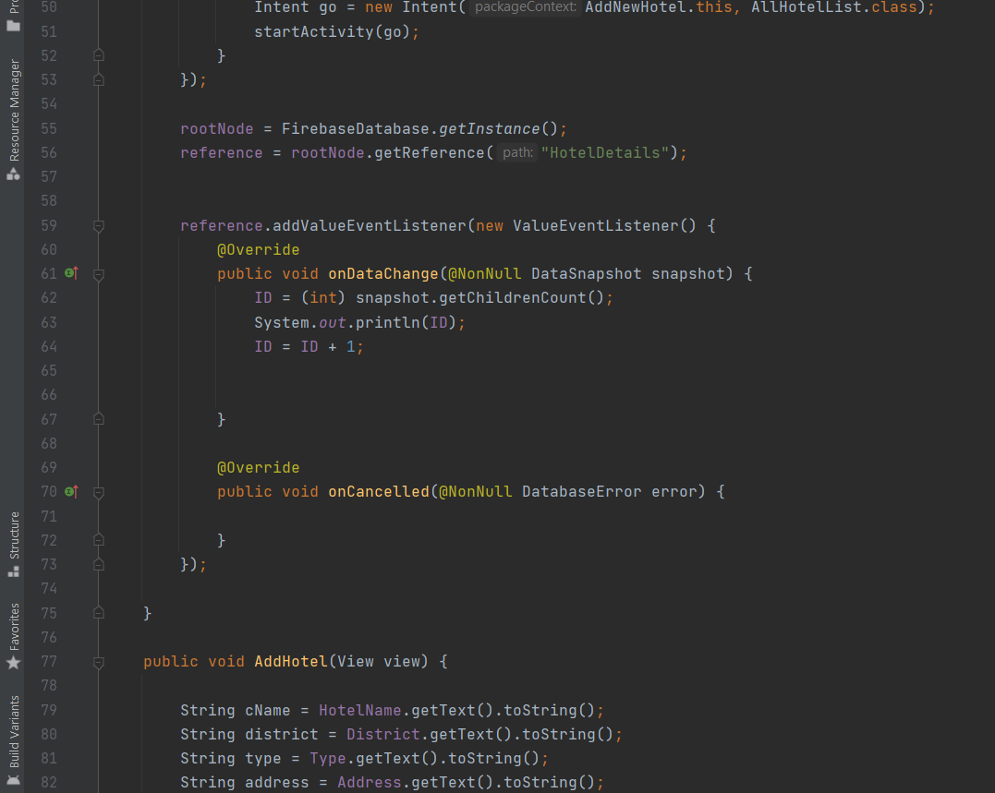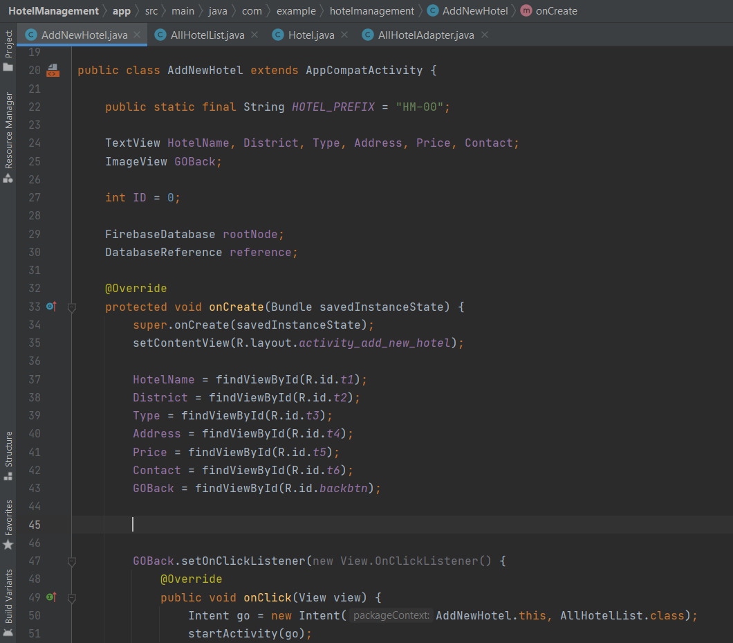

*Validations are done according to the below code; -*

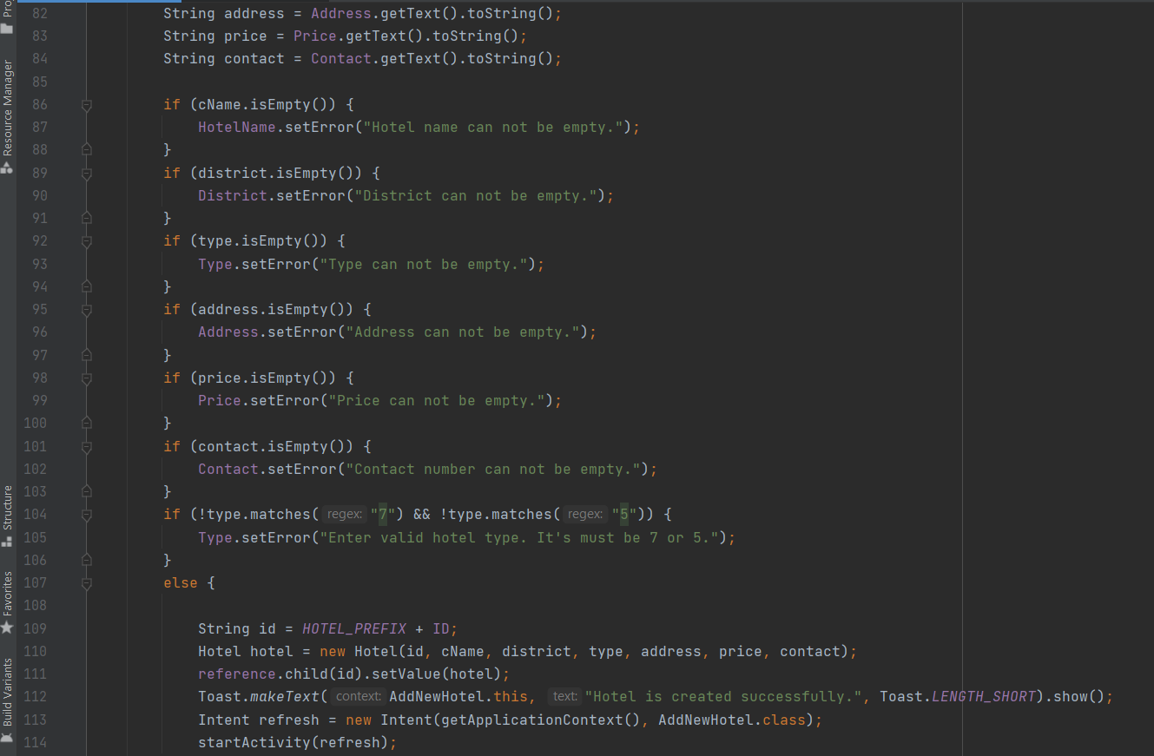

UPDATE Hotel details - All the details hotel name, district, hotel type, location, prize details of hotel packages, phone, and the brief description can edit from the update hotel details form. Admin can easily edit the relevant details by clicking UPDATE button. After clicking the update hotel button, the edited details will be updated successfully in the database

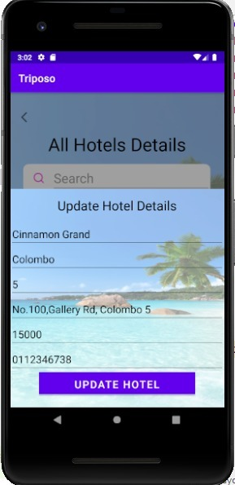

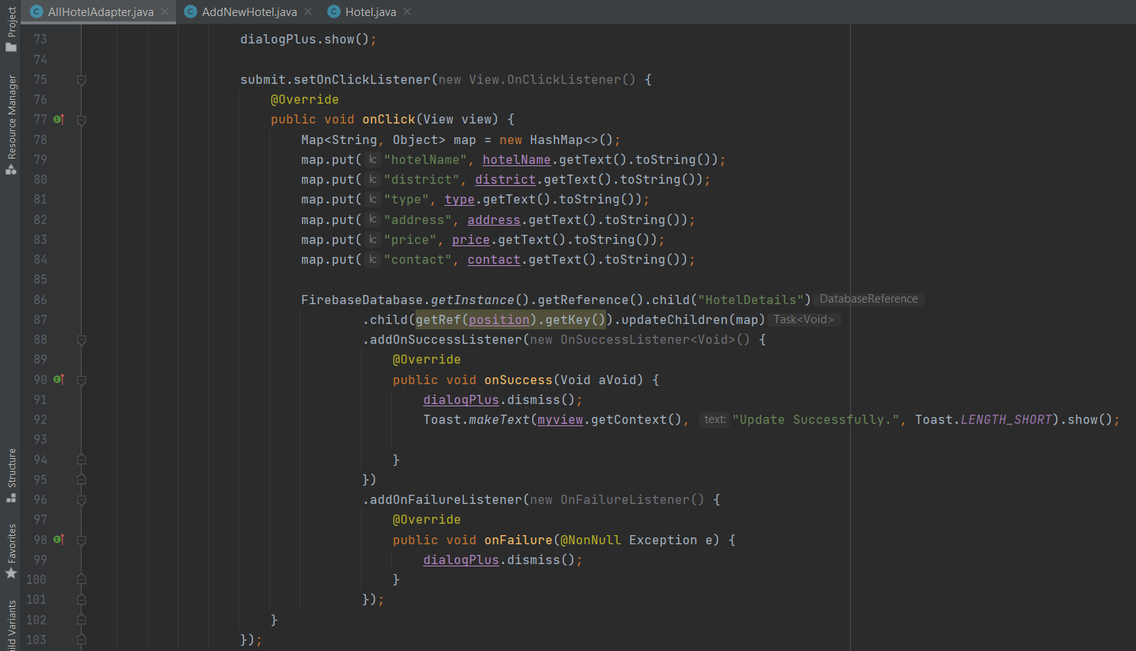

DELETE Hotel details - If admin wants to delete any hotel due to any reason admin can do easily from the delete section. By clicking DELETE button confirmation message will appear. By confirming it, admin can delete relevant hotel details successfully

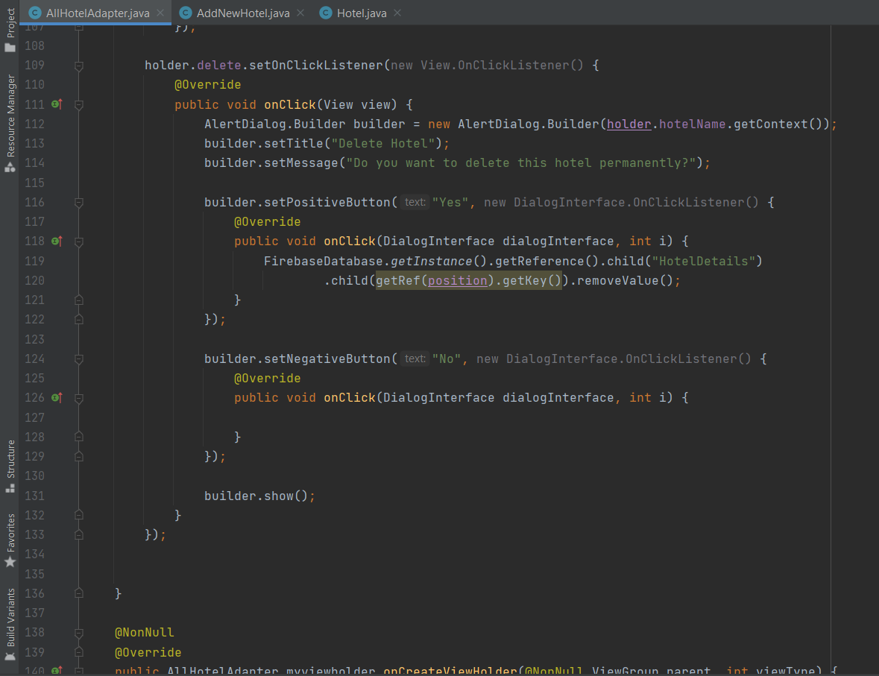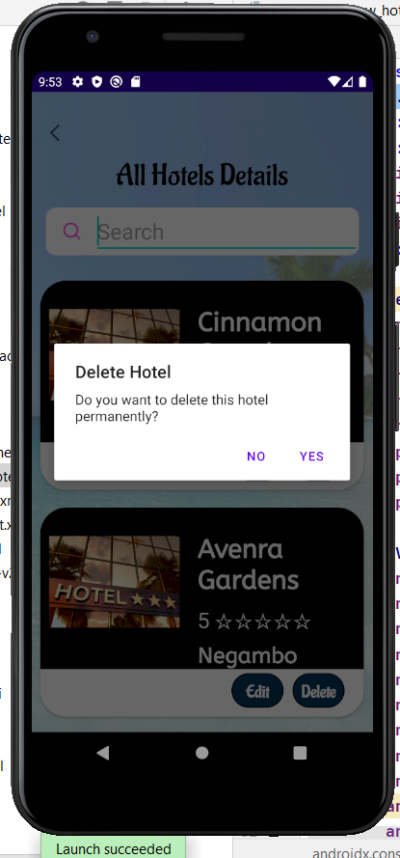

And above all these CRUD functions are belonging to the backend of the application.

Finally, hotels can calculate the payments of the users relevant to the rooms which they booked. Rooms have different prices due to consist of extra-facilities such as A/Cs, heaters, refrigerators and bed sizes. And some hotels will give 10% discounts for SAMPATH and BOC debit card users.

Test cases –

* All the required fields should be filled in order to add new hotel/ to insert details of a new hotel.
* Cannot enter invalid data such as contact as it should only consist of 10 digits.
* Cannot give a different digit rather than 5 and 7 for the hotel type, in case if you insert different digit (except 5 and 7) then it will display an invalid message.
* Toast messages will display if the details recorded successfully as well as for update and delete functions as well.

**GitHub Commit Graph**

**IT20152246 – Hotel Management**

**Crud operations and the entire functionality of the component.**